FarmCare UK Easy Guide to Setting Up the B1 EquiStop 9 Volt Energiser
This is our most popular electric fence energiser for horses - perhaps because it is so easy to set up and use.
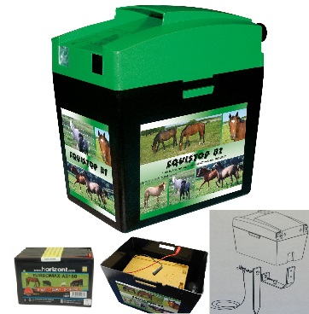
Step 1: Your 9 volt battery looks like this - with a red and black wire sticking out of the top. A 55Ah battery will last for approx 3 months, and a 150Ah battery will power your fence for about 9 months.
Step 2: Remove the green lid of your energiser (this is the hardest bit - but just squeeze the clips on the side and it will come off!) and place the battery inside the energiser.
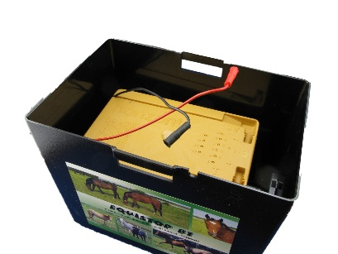
Step 3: Inside the lid you will see there are 4 terminals. We need the round ones nearest the edge of the lid. The largest of the two is the positive terminal. Because there are 2 sizes, you can't get them the wrong way around!
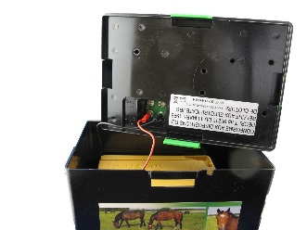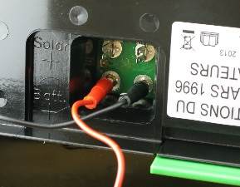
Step 4: Put the wires on, as per the picture. If you put the energiser on now, it will give you a shock! Carefully put the top back on, so it latches to the bottom.
Step 5: Attach the live fence wire (has a heart shaped end) to the Positive terminal on the left (the one with the lightning bolt). Tighten up the black knob to hold wire in place.
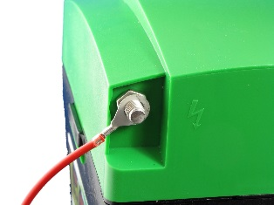
Step 6: Attach the earth stake wire to the terminal on the right (with the upside down T). Tighten up the black knob to hold wire in place.
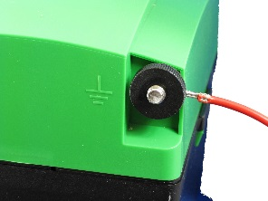
Step 7: The earth stake is assembled as per the picture. Make sure the wing nut is done up tightly. The earth stake slides into the slot at the bottom of the energiser. Alternatively, the earth stake can be put in the ground and the energiser can sit next to it.
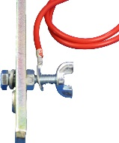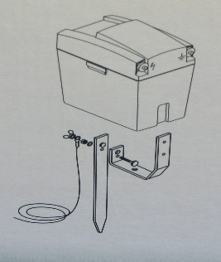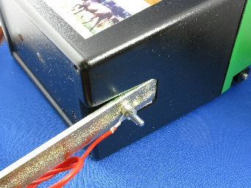
Step 8: Your energiser is now ready to us! Slide the heart shaped wire over your electric fence tape or rope and switch it on. The light will start flashing and your electric fence is live.
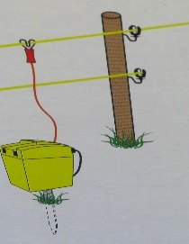
Remember to keep checking your energiser to ensure your battery life is sufficient. Regularly check your fence to make sure there is nothing touching it that can 'earth' it (this will waste your battery and create a weak fence). If your tape or rope breaks, please don't tie knots as this will prevent the electrical pulses from flowing around the fence properly. Instead, please use tape or rope connectors.
If you have any questions, please give us a call. We are always happy to help.
FarmCare UK
Electric Fence Specialists
01323 406212

